

AWS MINI-PROJECT DOCUMENTATION – 2:
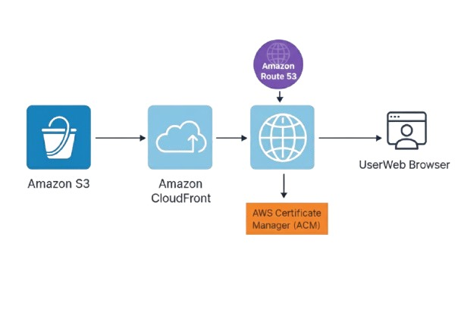
📘Project Title:
Static Website Hosting Using AWS S3, CloudFront, ACM & Route 53.

📝 Project Overview:
The project showcases how to host a secure, scalable, and high-performance static website using AWS S3, CloudFront, ACM, and Route 53.

🧩 Architecture Overview (Points):
- Amazon S3: Stores static website files securely and cost-effectively.
- Amazon CloudFront: Delivers content globally with caching for low latency.
- AWS Certificate Manager (ACM): Provides free SSL/TLS certificates for HTTPS encryption.
- Amazon Route 53: Manages domain registration and DNS routing.
- Origin Access Control (OAC): Secures S3 by allowing only CloudFront to access bucket content.
- S3 Block Public Access: Ensures the bucket cannot be publicly accessed directly.
- HTTPS Enforcement: CloudFront forces secure traffic for all website access.

⚙️Setup Steps:
Step 1: Create S3 Bucket.
- Open S3 → Create Bucket.
- Bucket name = your domain (e.g., mywebsite.com).
- Keep Block Public Access ON.
- Create Bucket.
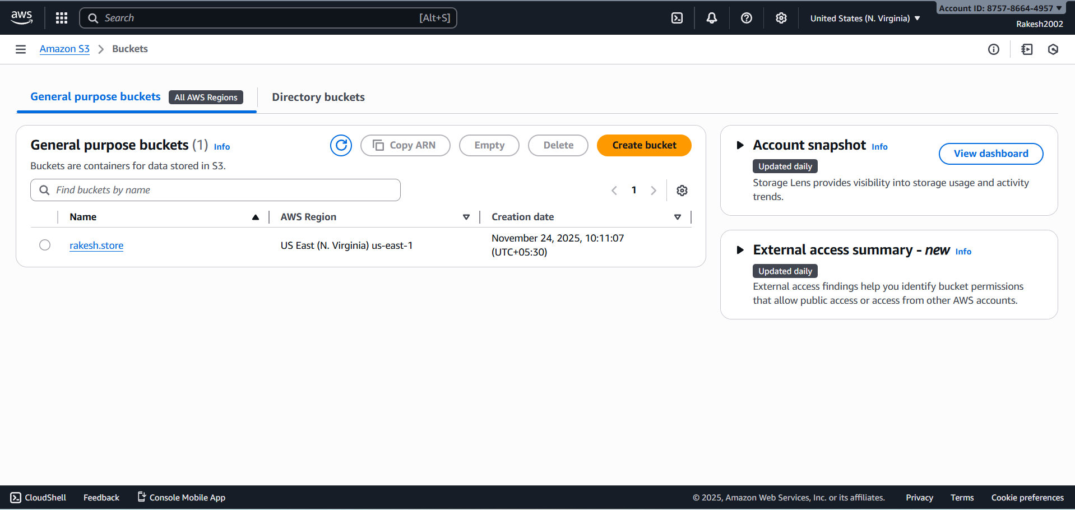

Step 2: Upload Website Files.
- Open your bucket → Upload.
- Upload index.html and all website assets.
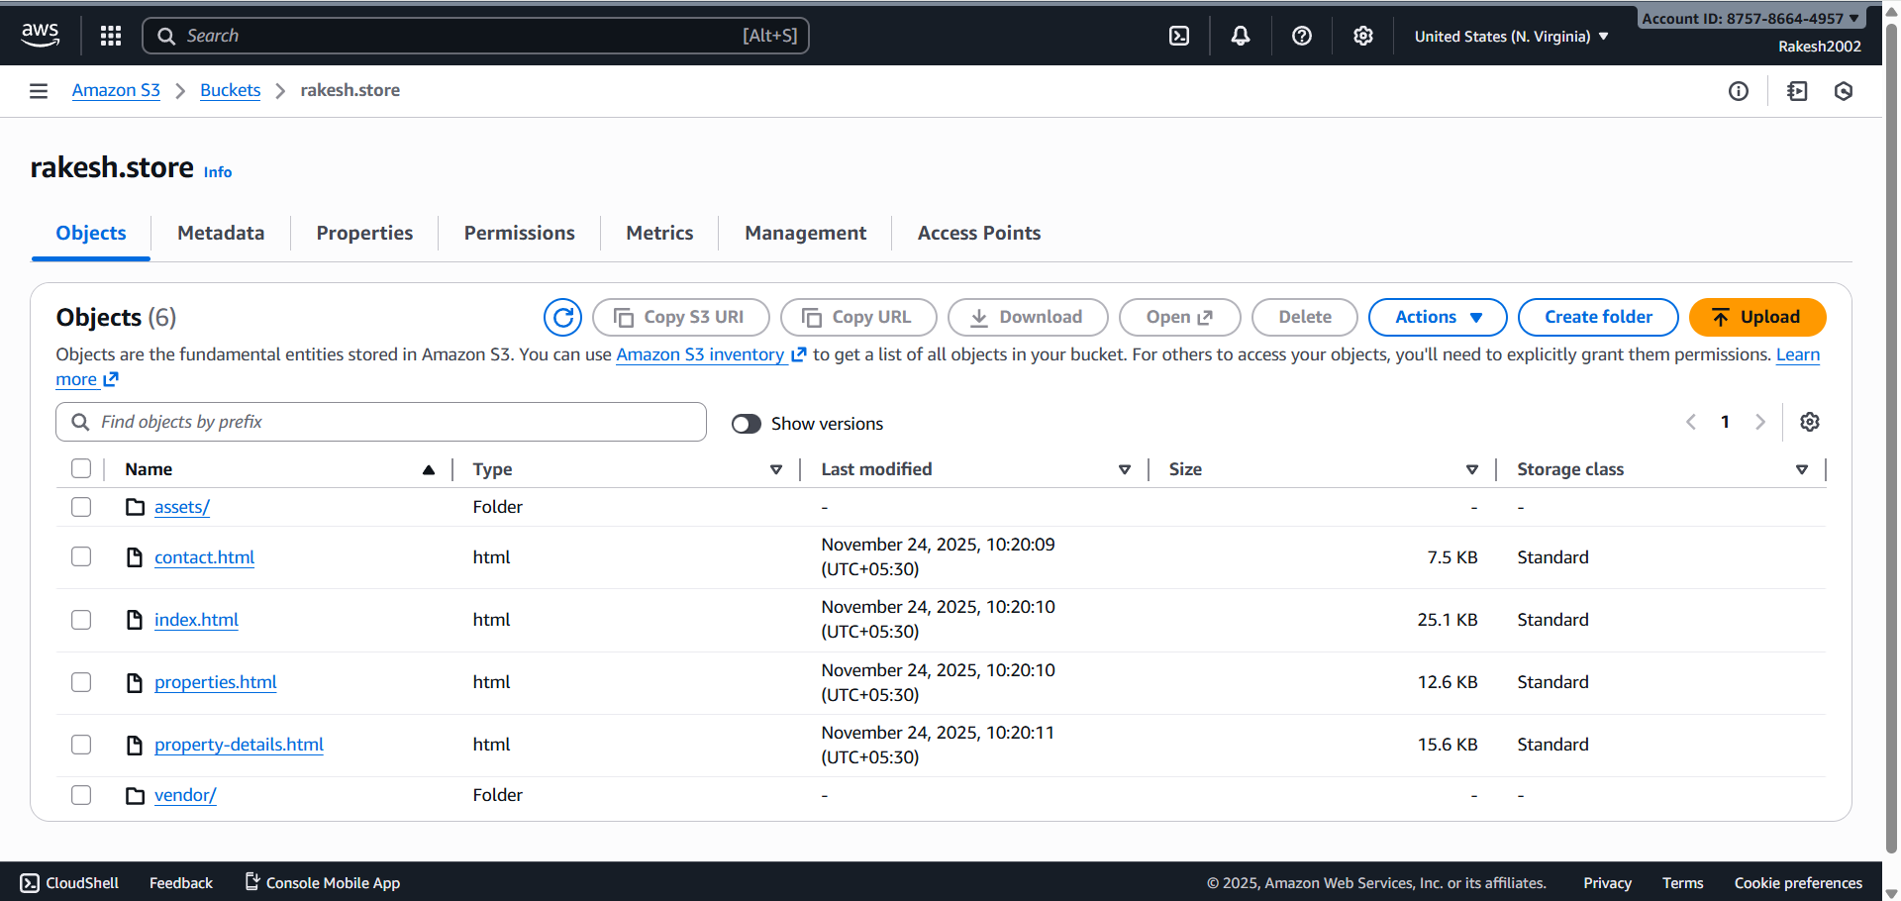

Step 3: Create CloudFront Distribution.
- Go to CloudFront → Create Distribution.
- Select S3 bucket as origin.
- Enable OAC (Origin Access Control).
- Set Default Root Object = index.html.
- Create distribution.
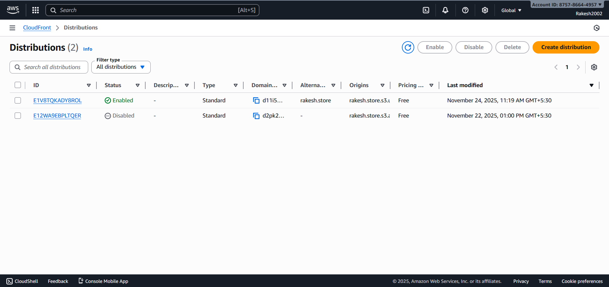

Step 4: Apply Bucket Policy for OAC
- In CloudFront → Origins → Select S3 origin.
- Click 'Copy Policy'.
- Paste in S3 → Permissions → Bucket Policy.
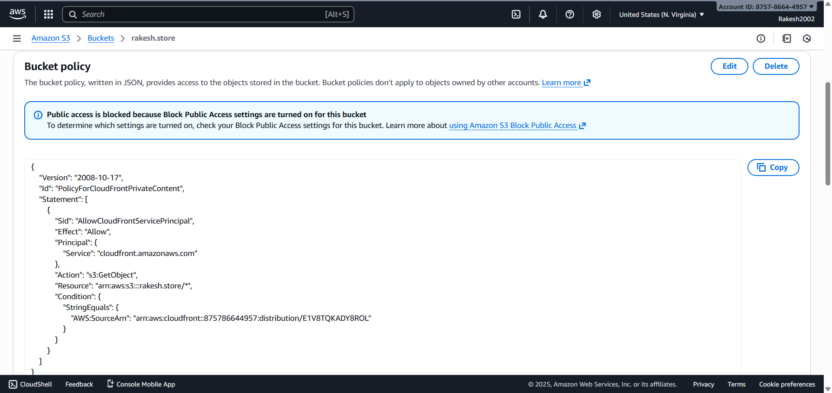

Step 5: Request ACM SSL Certificate
- Open ACM (Region: us-east-1).
- Request public certificate.
- Add domain name.
- Choose DNS validation.
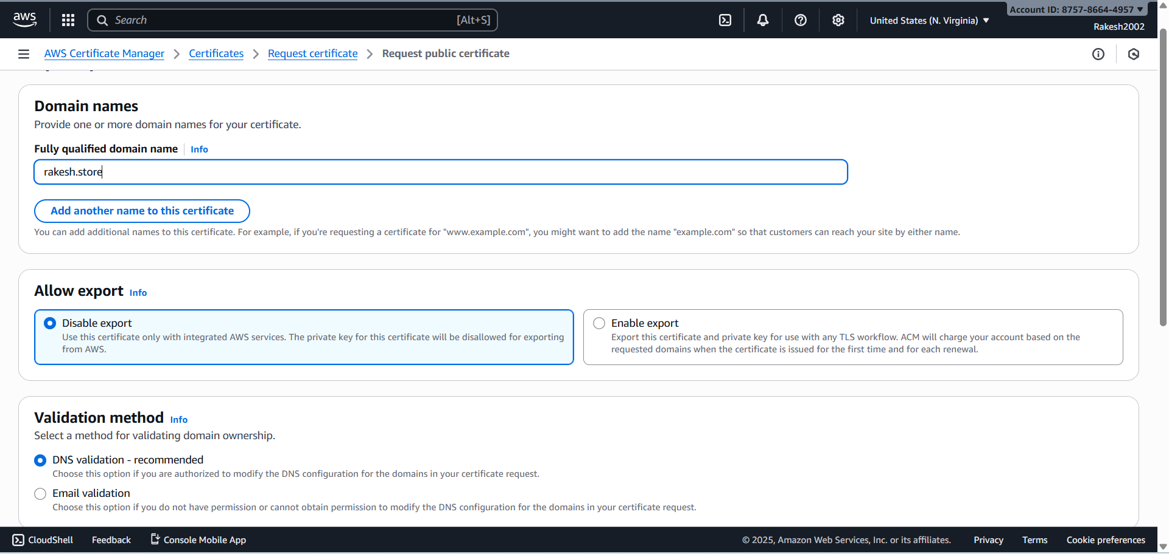

Step 6: Add ACM CNAME in Route 53
- Open Route 53 → Hosted Zones.
- Create CNAME record.
- Paste Name + Value from ACM.
- Certificate becomes ISSUED.
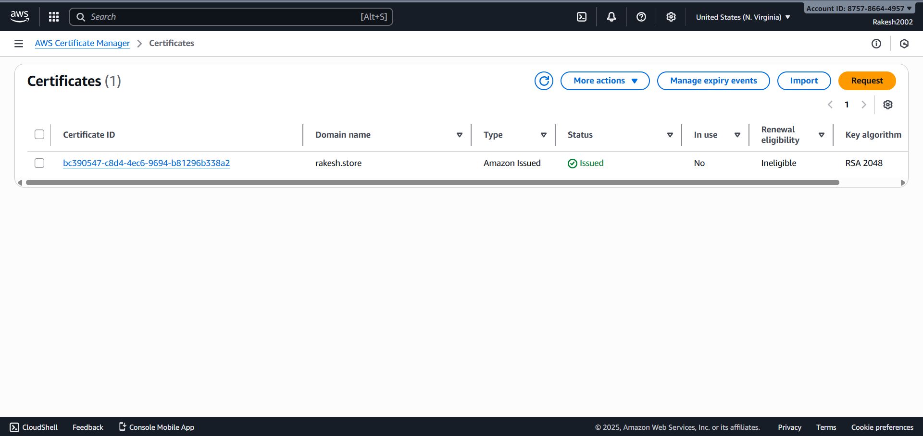

Step 7: Attach Certificate to CloudFront
- Open CloudFront → Distribution Settings.
- Edit.
- Choose ACM certificate.
- Save.
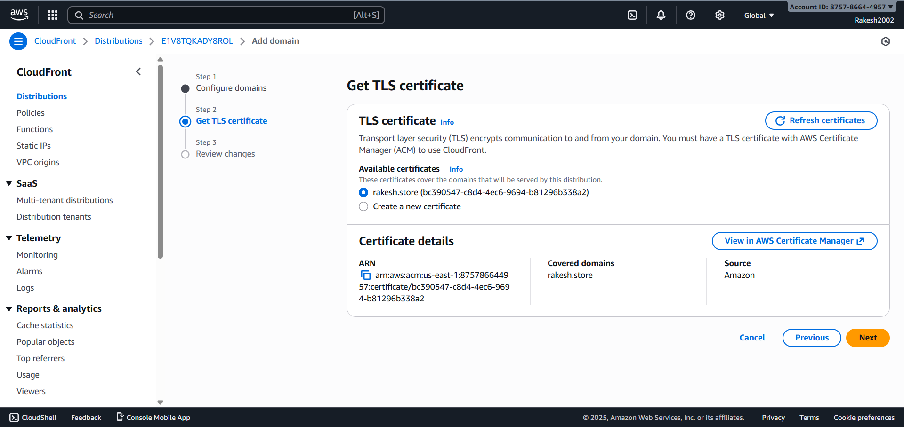

Step 8: Create Route 53 A-Record
- Go to Hosted Zones → your domain.
- Create A Record.
- Turn ON Alias.
- Select CloudFront distribution.
- Save.
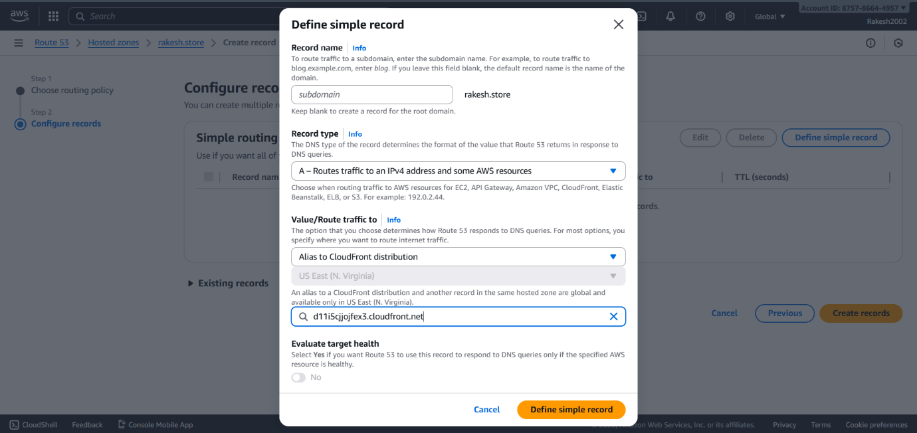

Step 9: Test Website
- Open https://rakesh.store

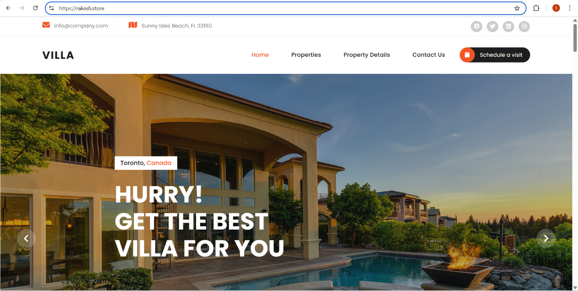

- Website loads with HTTPS and CloudFront.
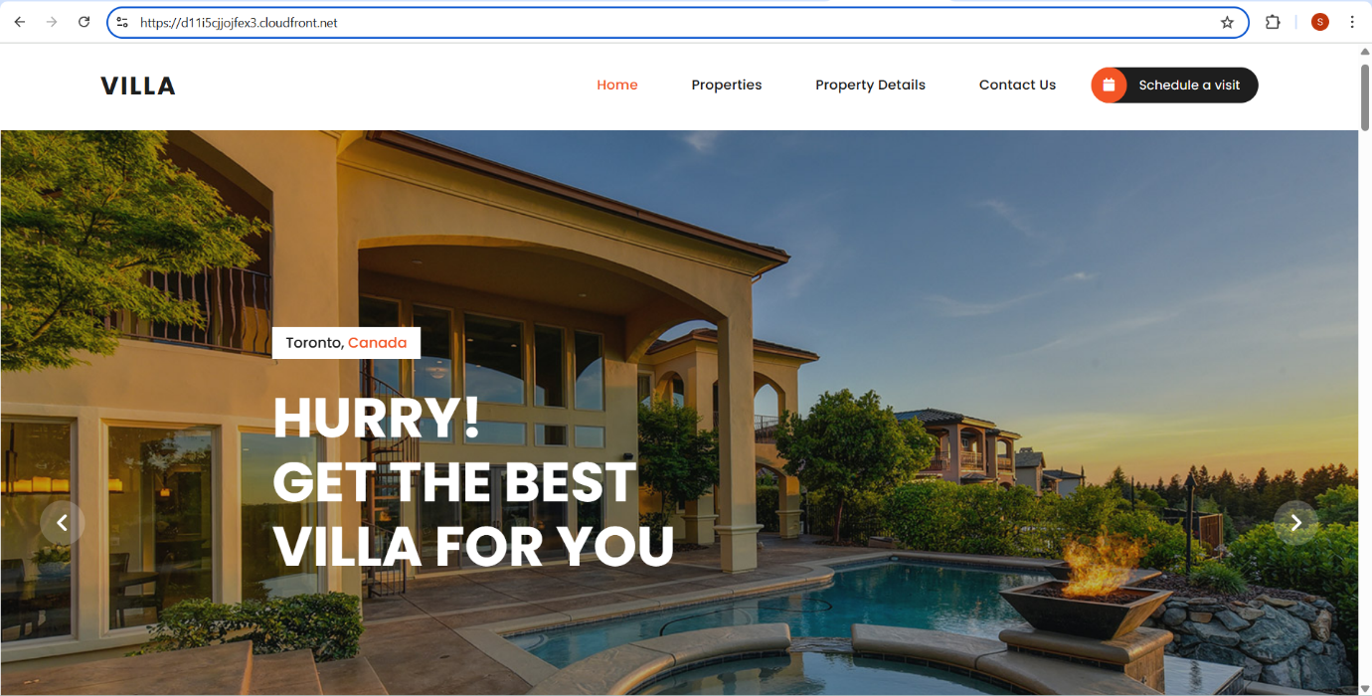

Hosted Zones in Route 53:
Route 53 Hosted Zones store DNS records for your domain. In this project, you create a public hosted zone, add CNAME for certificate validation, and create an A-record to point the domain to CloudFront.

